# **Final Project – EleNa**

1. Testing the UI:
   1. Test that upon starting the software,
      1. The webpage displays the map correctly, centered at Amherst
      2. Text boxes are blank and activated
      3. Toggle button is at “Select Map”

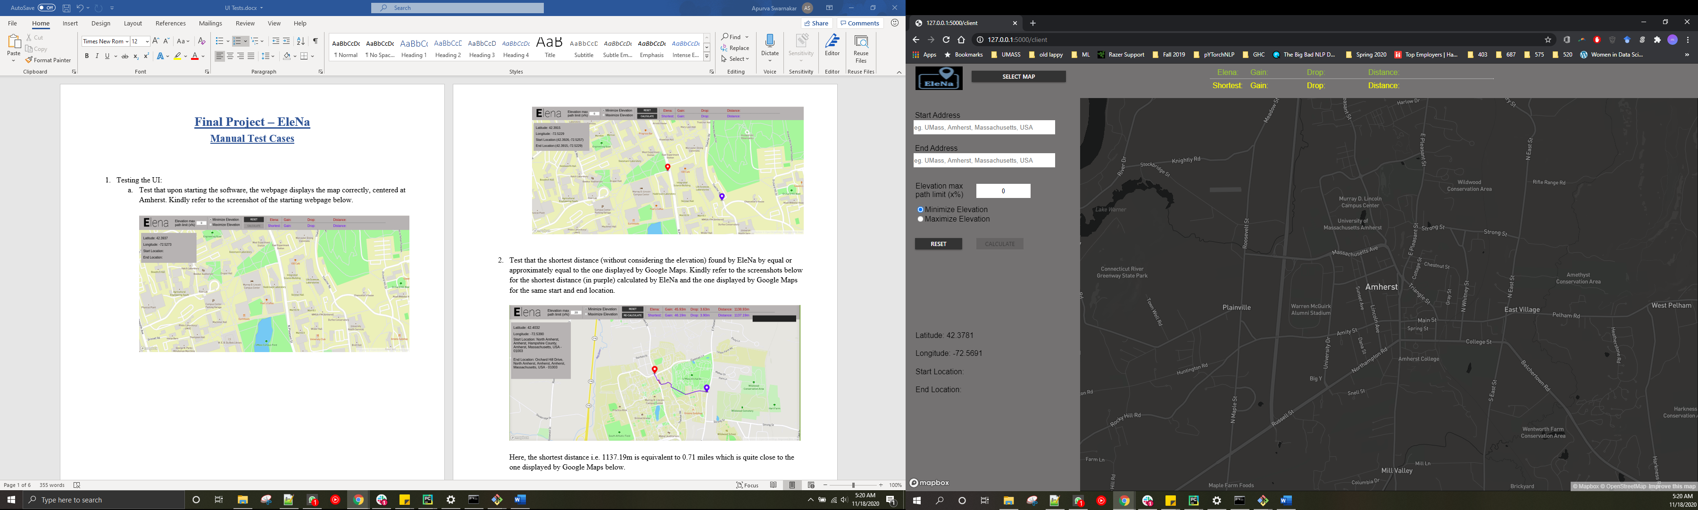

1. Test that the map is clickable when toggle button is on “Type Address”

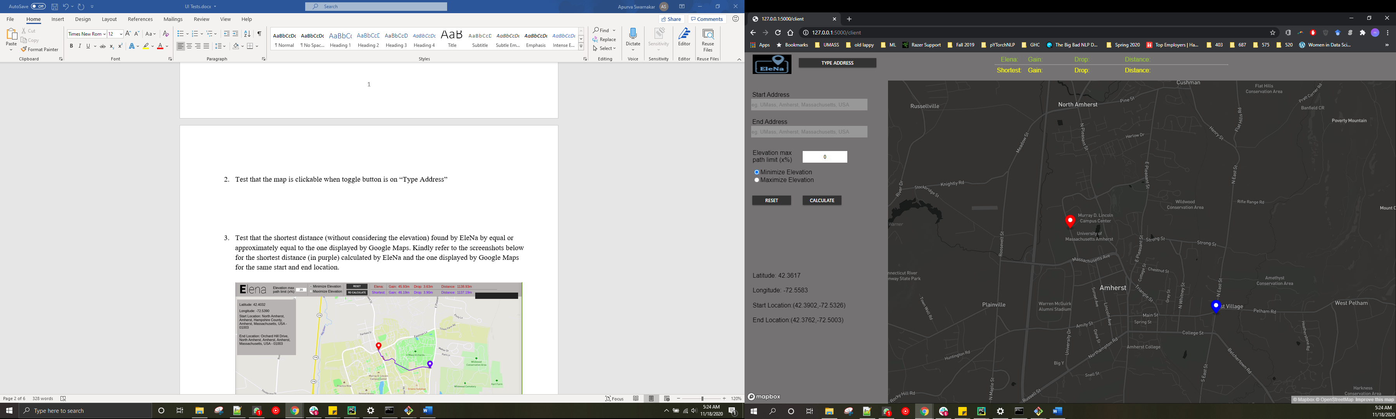

1. Test the text boxes are taking input when toggle button is on “Select Map”

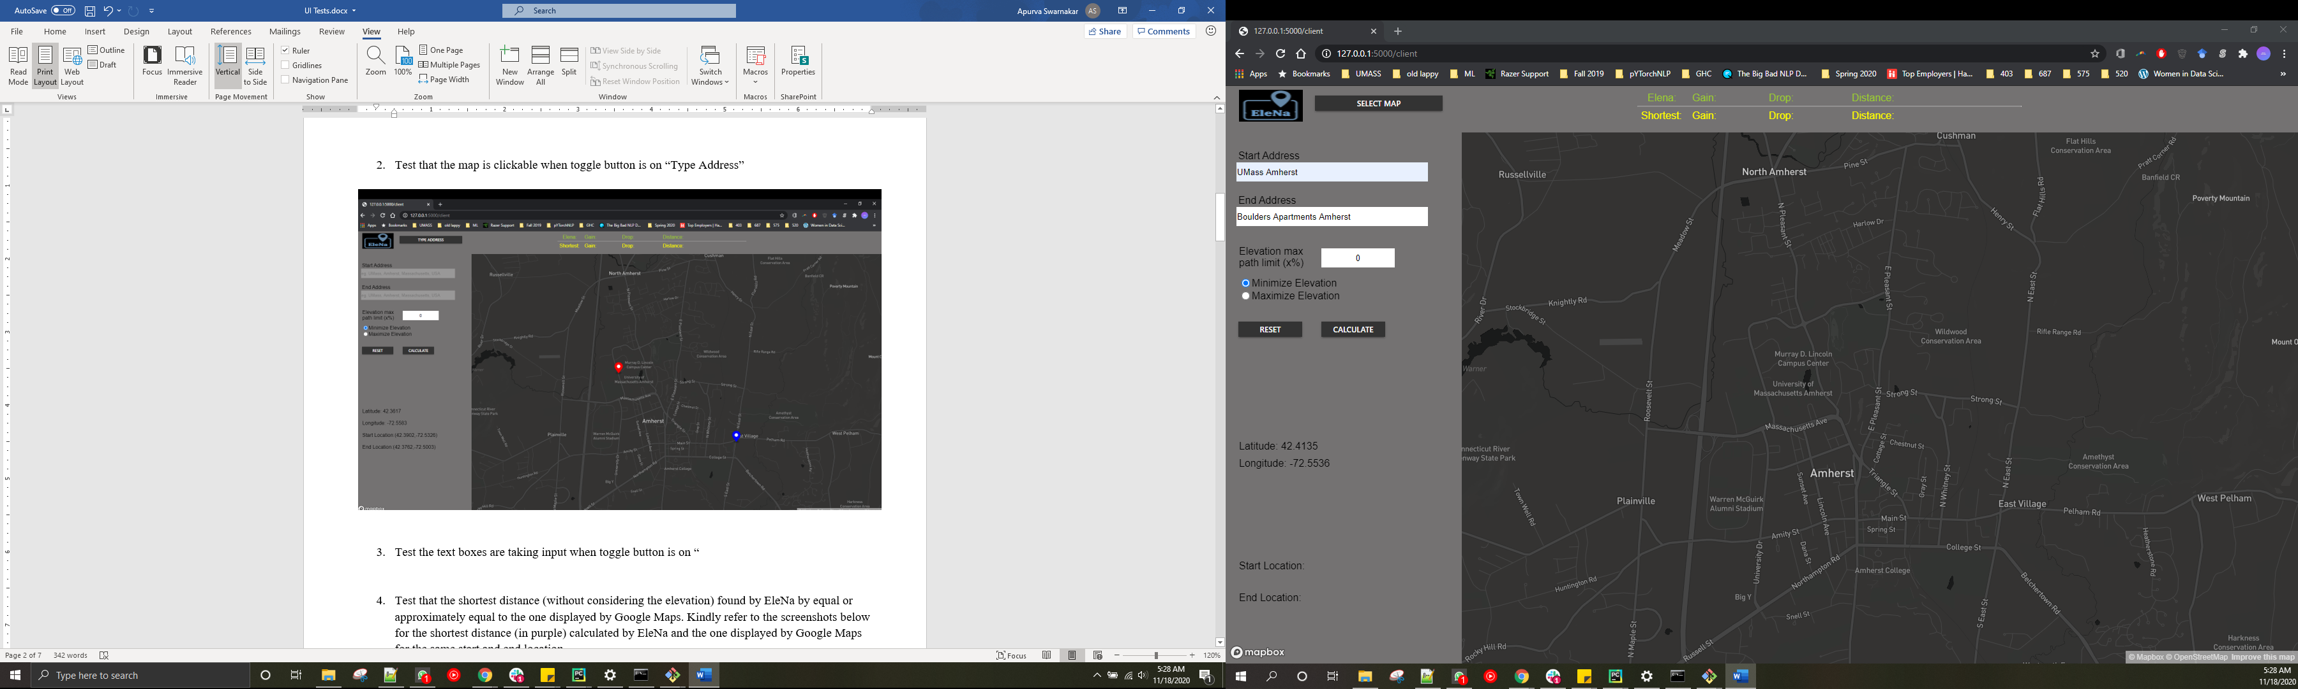

1. Test if we are getting correct coordinates from pin dropping

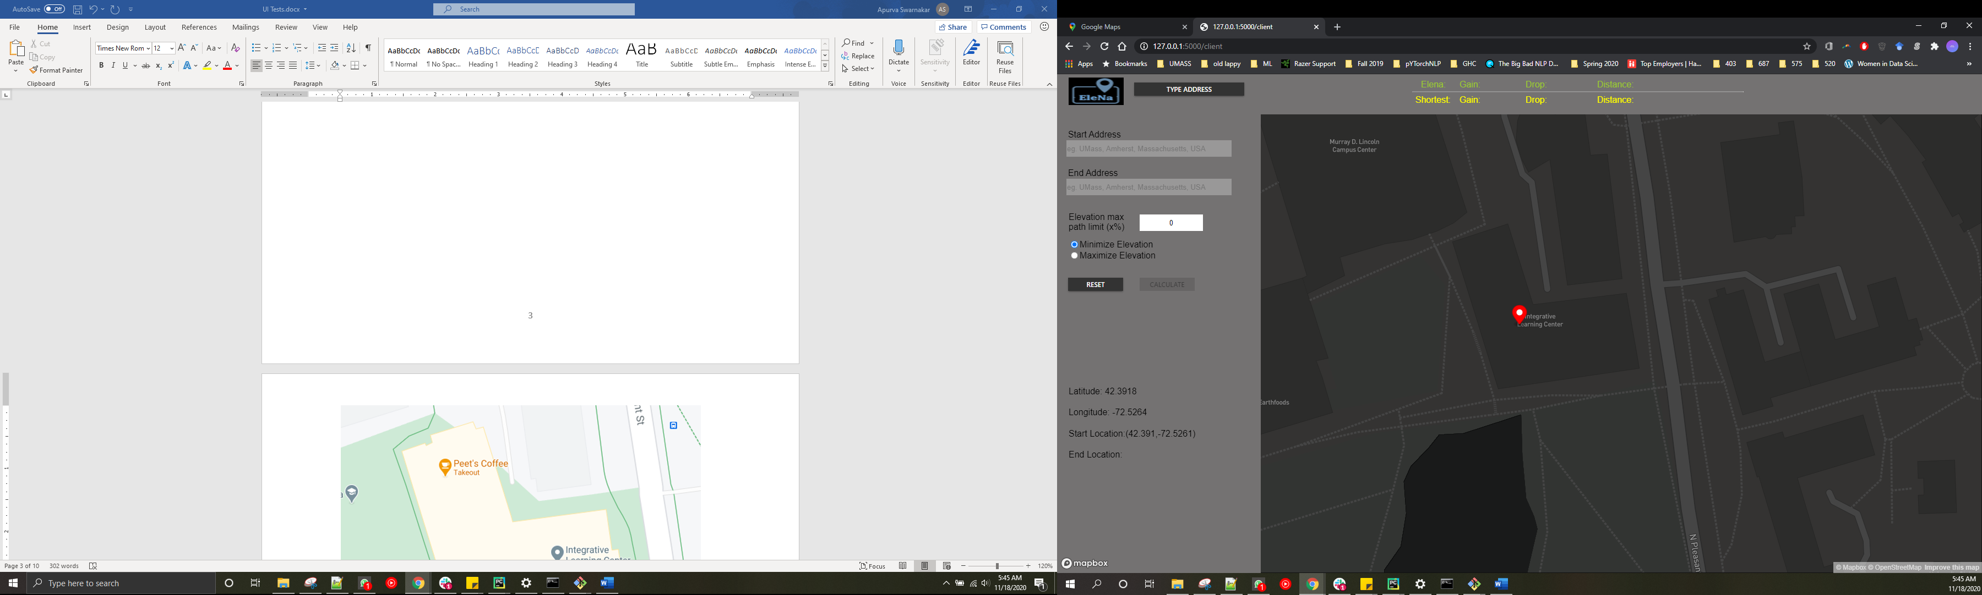

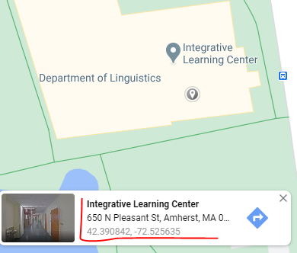

1. Test if we are getting correct address from text box input

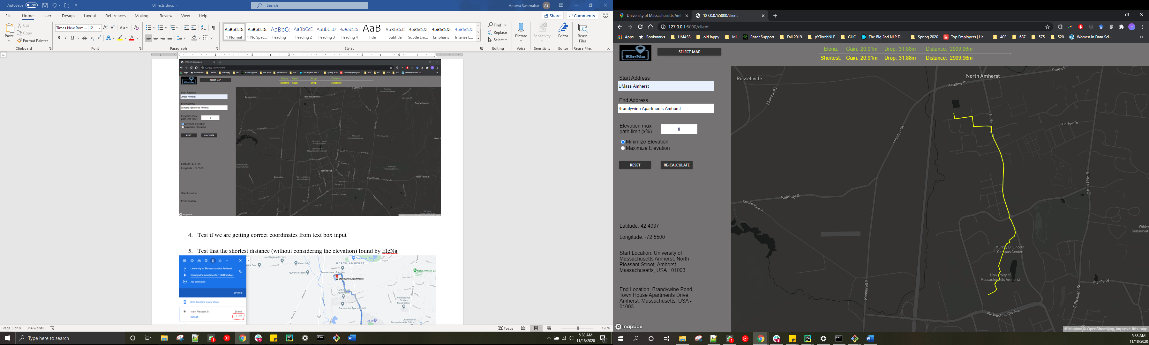

1. Test that the shortest distance (without considering the elevation) found by EleNa

